## Creating the project

### Tools used:

* Visual Studio 2017

### Steps:

1. Open Visual Studio
2. Under **File** menu, select **New** > **Project**
3. Copy the options below, then hit OK.

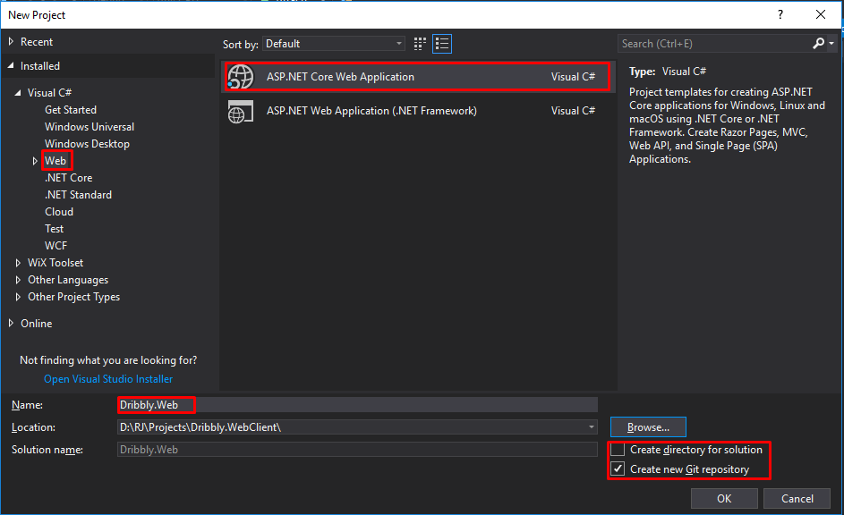

1. On the next screen select the options below, then hit OK.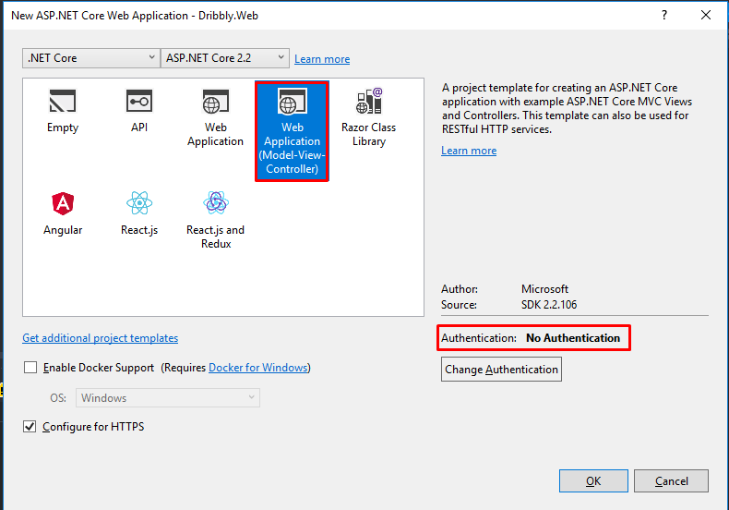

## Requirements for Phase 1

* Landing page
* Main Navigator
* Registration and Login
  + Photo upload
* Player profiles
  + Creation
  + Search
* Courts
  + Registration
  + Search
  + Scheduling
* Team Management
* Games management

## Types of Pages

### Search Page

Page used for searching players, courts, games, etc

### Browser Page

Page used for viewing player details, court details, game details

## Conventions

* Prefix components, directives, filters with ‘drbbly’
* Add a newline character at the end of every files if allowed

## Publishing

### Local IIS Server

* Open IIS Manager

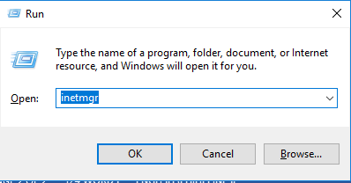

* Add Website

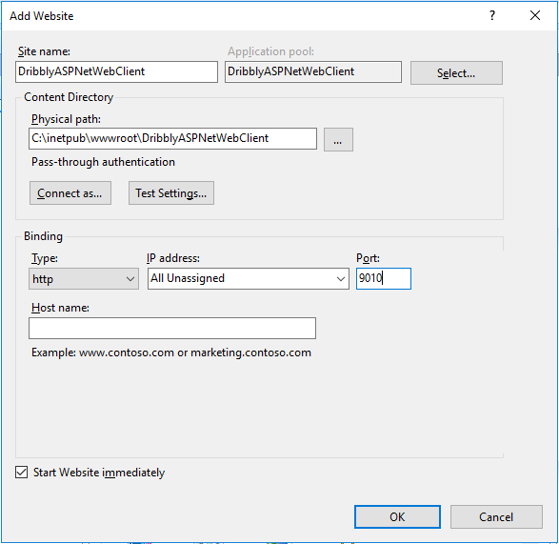

* Click OK to create the website
* Run Visual Studio as admin, then open the solution
* In Visual Studio, right-click on the project then select Publish
* Click on New Profile…
* Select “IIS, FTP, etc”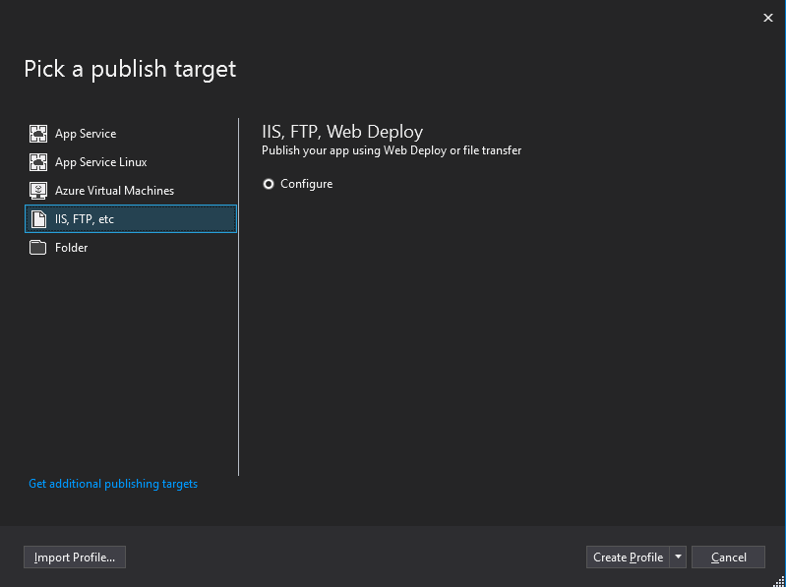
* click on “Create Profile”

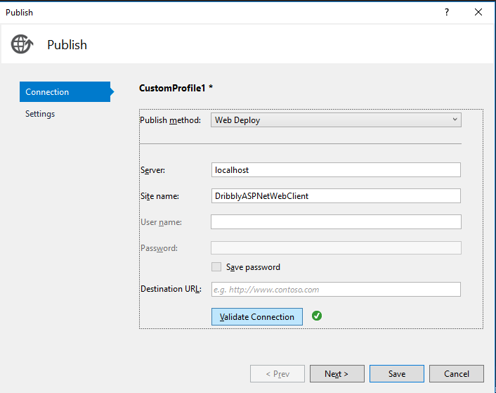

* Click Next
* For now, set Configuration to Debug, until the website is configured for release (minify files, etc.)

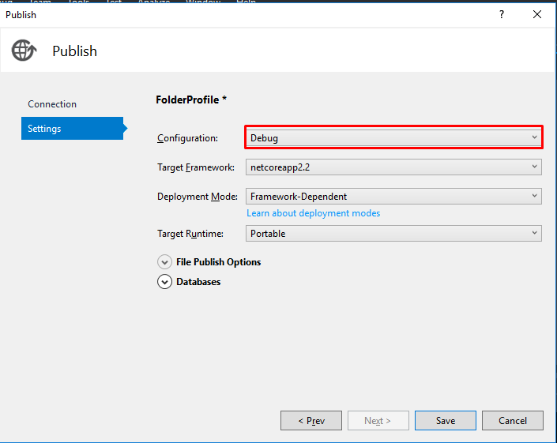

* Click Save.

#### Accessing local IIS Instance from another machine via IP address

1. Add Website a binding

* Open IIS Manager, select the website, and then click on “Bindings”

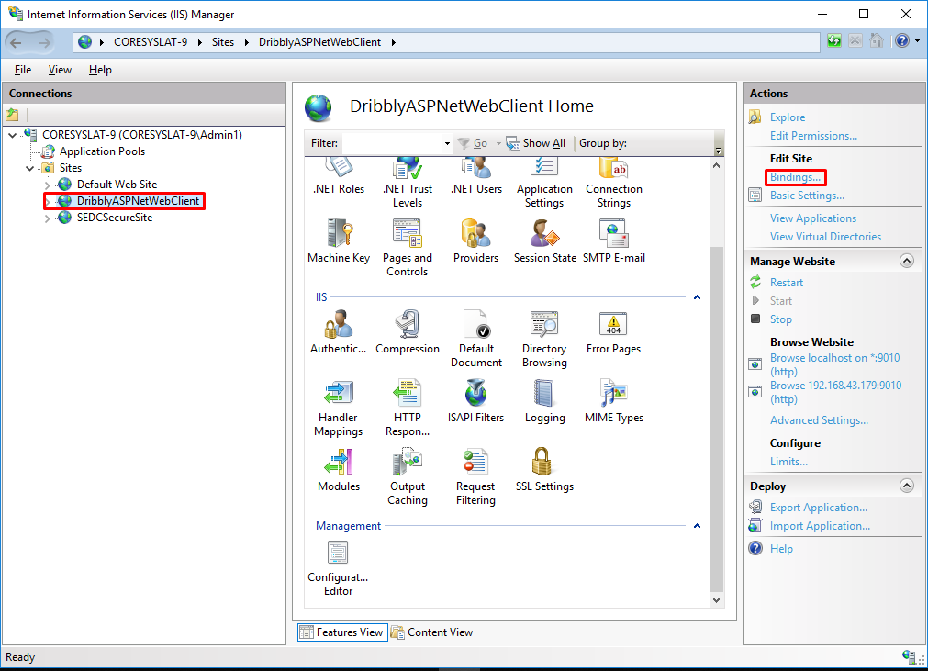

* Click “Add”
* Set type to “http”, select the IP from the dropdown, then enter the port. Leave Host Name empty. (Note: IPs will only show in the dropdown if the network is already connected to the network. Otherwise, type in the IP address. We can also enter * to allow it to be accessed whatever the current IP address) Click OK

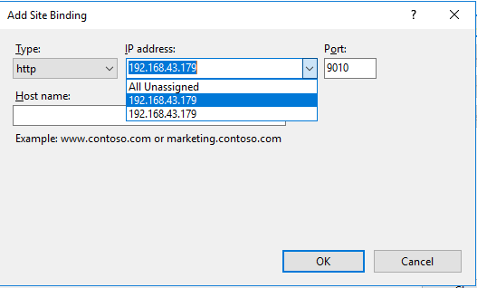

1. Add Firewall rule

* Open Firewall advanced settings window
* Select “Inbound Rules” then click on “New Rule…”

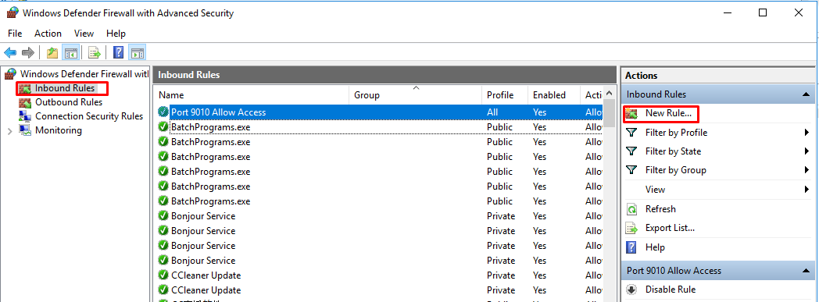

* Select “Port”, then click Next

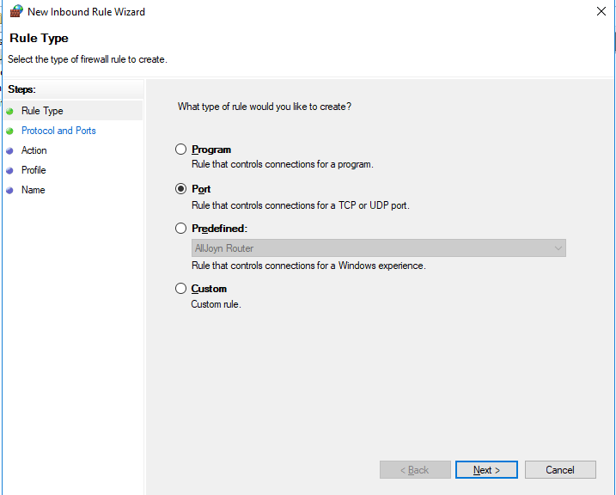

* Select TCP, then enter the same port number used in the previous step. Click Next

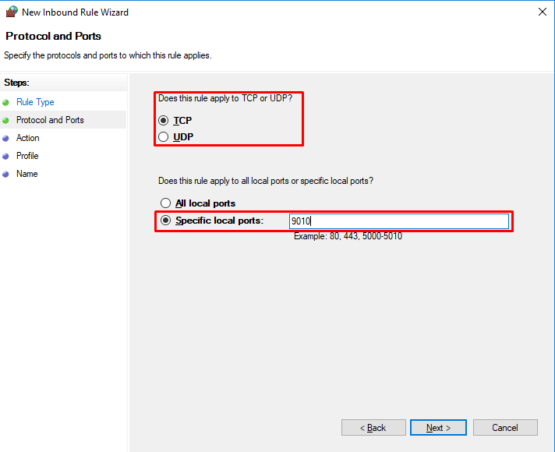

* Select “Allow Connection”. Click Next

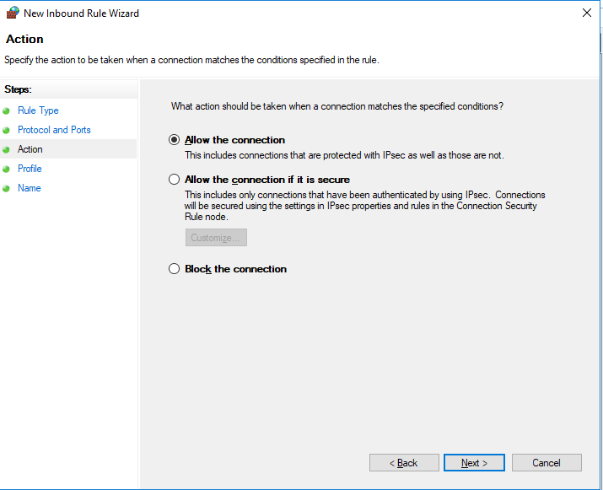

* Check all options. Click next

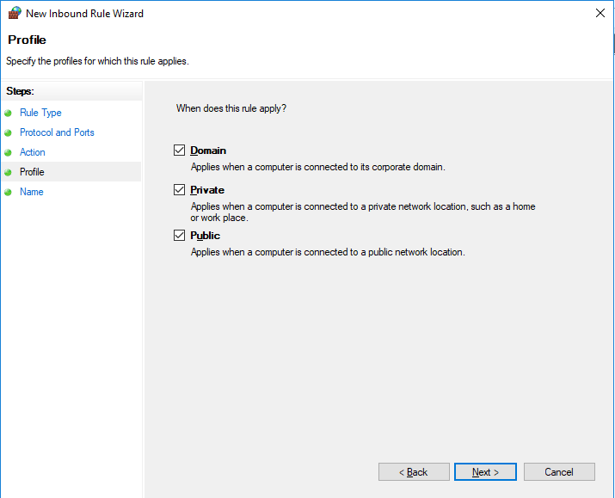

* Enter a name for the rule, then click Finish

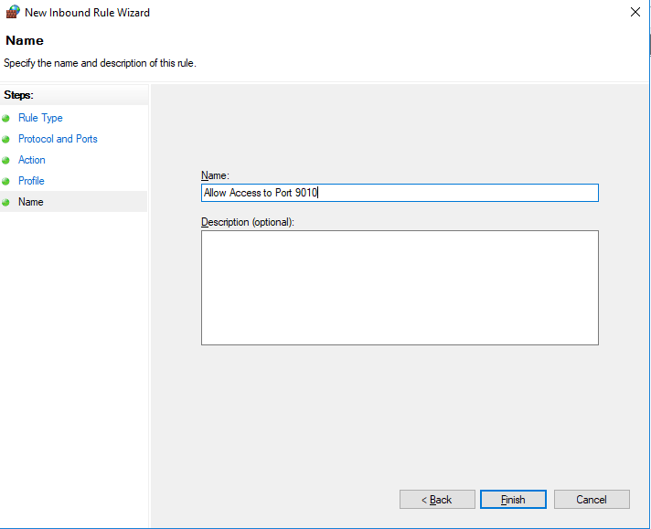



* Any device on the same network should now be able to access the website using the IP address and port (example: http//:192.168.43.179:9010)

### Test Server (somee.com)

|  |  |
| --- | --- |
| Site Title | Dribbly Web Client |
| Credentials | rjpablo112/encrypt(somee) |
| Site name | [http://dribbly001.somee.com](http://dribbly001.somee.com/); [http://www.dribbly001.somee.com](http://www.dribbly001.somee.com/); |
| FTP Addresses | [ftp://dribbly001.somee.com](ftp://rjpablo112@dribbly001.somee.com/); [ftp://www.dribbly001.somee.com](ftp://rjpablo112@www.dribbly001.somee.com/); |
| IP Address | **66.85.73.158** |

To publish to this server, publish the application to a folder and then upload the files to the root of the server.

## Database Information

Local SQL Server database

credentials: test1/encrypt(test1)

version: 2014

## App Flow

Under Courts show limited number of Featured Courts, New Courts, etc. A “more…” link at the bottom of each category would load more items for that category or show all the items in a modal with pagination

## What to do next?